**Project Design Phase**

**Problem – Solution Fit Template**

|  |  |
| --- | --- |
| Date | 15 February 2025 |
| Team ID | PNT2025TMID02554 |
| Project Name | global malnutrition trends analysis(1983 to 2019 ) |
| Maximum Marks | 2 Marks |

**Problem – Solution Fit Template:**

Problem-Malnutrition has been a persistent global issue, affecting millions of people across different regions and demographics. Understanding long-term trends in malnutrition is crucial for policymakers, healthcare professionals, and organizations working to combat hunger and undernutrition. However, the lack of comprehensive data analysis over time makes it difficult to identify patterns and implement effective interventions.

Solution -Our project analyzes malnutrition trends from 1983 to 2019 using historical data, statistical modeling, and data visualization techniques. By identifying key patterns, regional disparities, and contributing factors, our research provides insights that can help governments and organizations make informed decisions to tackle malnutrition effectively.

**Purpose:**

✅ **Solve complex problems in a way that fits the state of your customers.**

✅ **Succeed faster and increase your solution adoption by tapping into existing mediums and channels of behavior.**

✅ **Sharpen your communication and marketing strategy with the right triggers and messaging.**

✅ **Increase touch-points with your company by finding the right problem-behavior fit and building trust by solving frequent annoyances, or urgent or costly problems.**

✅ **Understand the existing situation in order to improve it for your target group.**

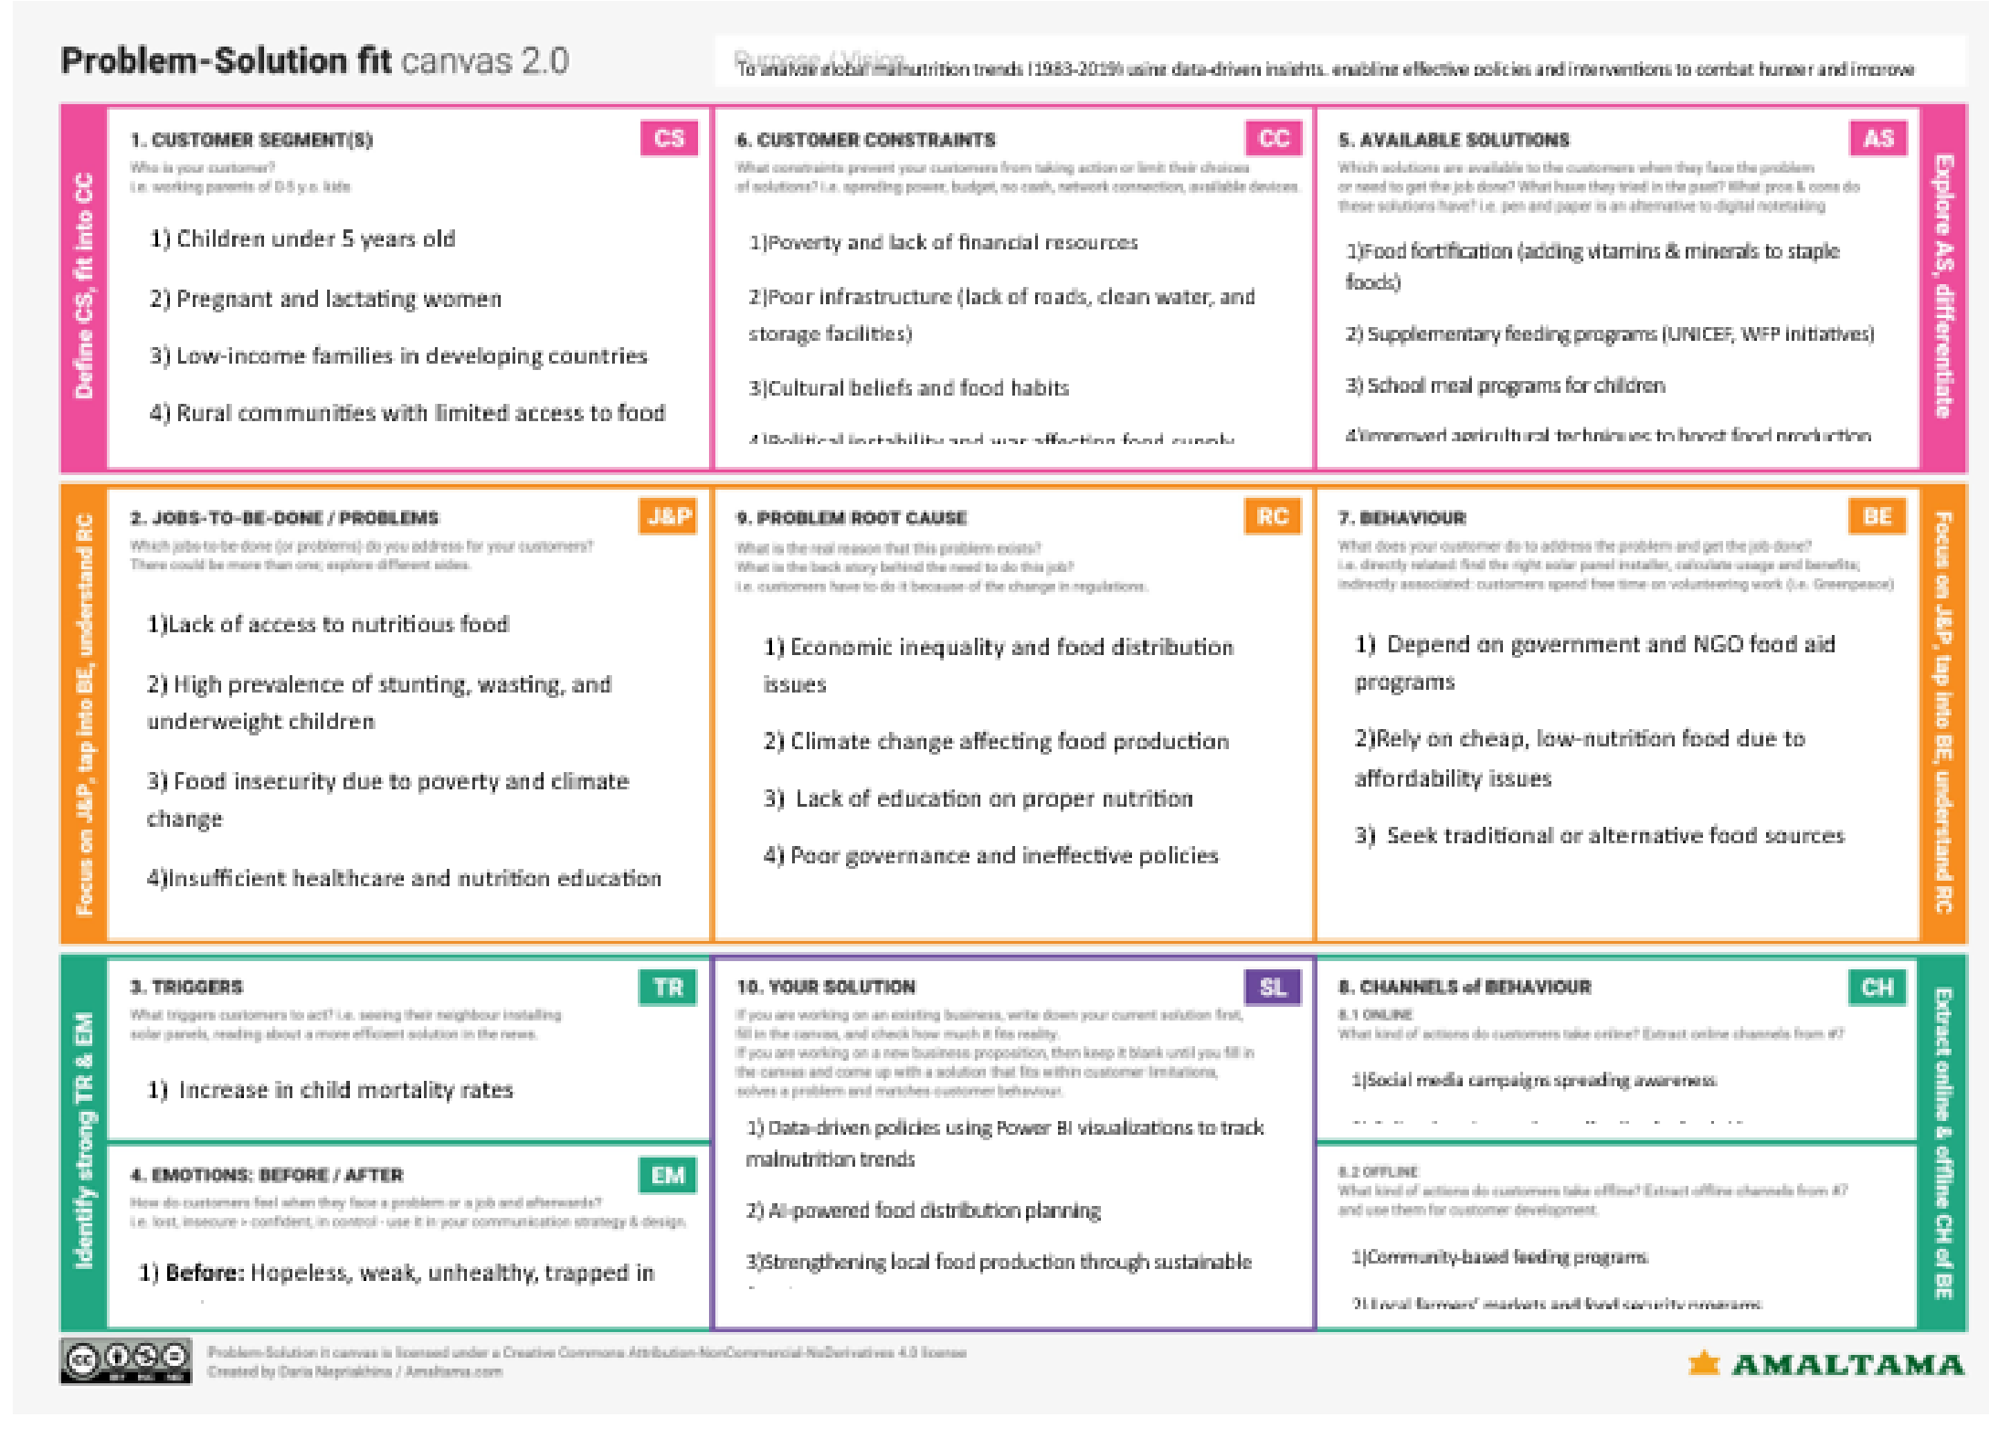**Template:**

References:

1. <https://www.ideahackers.network/problem-solution-fit-canvas/>
2. <https://medium.com/@epicantus/problem-solution-fit-canvas-aa3dd59cb4fe>